OPEN SEMINAR

Right Waste, Right Place: Duty of Care in the construction sector

9th May 2017

Room S0.29, South Building, Queen’s Buildings, The Parade, Cardiff University CF24 3AA

Anyone who produces, treats, disposes, moves or arranges the movement of waste has a legal Duty of Care to ensure that waste is managed properly.

Following Duty of Care is vital both to ensure your own company’s compliance with the law, but also to ensure that your waste is passed on to someone who will also manage and handle it correctly.

This free seminar will focus on the specific requirements of Duty of Care for the construction sector and will provide the views of the regulator, the waste producer and the waste management sector.

If you work in or are involved with the construction sector, this seminar will help you understand your responsibilities and identify how you can comply with the requirements. A question and answer session will give you the opportunity to pose your questions to the experts.

The programme for the day is shown below.

There will also be an opportunity to meet other businesses involved in the Construction supply chain, local councils and training providers.

Please e-mail info@rightwasterightplace.com or call 0808 123 0014 to register for this event.

Meeting kindly sponsored by WPS, Sustainable Direction and DRIM

SEMINAR – RIGHT WASTE, RIGHT PLACE
Duty of Care in the construction sector

9th May 2017

Room S0.29, South Building, Queen’s Buildings, The Parade, Cardiff University CF24 3AA

PROGRAMME
09.30 – 10.00 Arrival, reception with tea & coffee

10.00 – 10.10 Welcome & Introduction to Right Waste, Right Place
Chair of seminar – Robert Little, CIWM Cymru Wales

10.10 – 10.35 What should compliance look like?
Geraint Richards – Natural Resources Wales

10.35 – 11:00 Right Waste Right Place Campaign
Sam Corp – Right Waste, Right Place & WESA

11.00 – 11.30 A contractor/consultant’s view
Lara Ayris – Waste Plan Solutions Ltd

11.30 – 11.45 Coffee break and networking

11.45 – 12.00 The importance of data
Kris Atkins – DRIM

12.00 – 12.30 What to do if it goes wrong…
Dr. Anna Willetts, Slater and Gordon

12.30 – 13.00 Q&A, panel discussion & closing remarks

13.00 – 14.00 Lunch and networking

Meeting kindly sponsored by WPS, Sustainable Direction and DRIM

Room S0.29, South Building
Queen’s Buildings
The Parade
Cardiff University
Cardiff CF24 3AA

029 2087 9999
http://www.cardiff.ac.uk

Please report to the Porters’ Lodge for directions. It is located in the ground floor of the Trevithick Building (the first building on the right after the entrance).
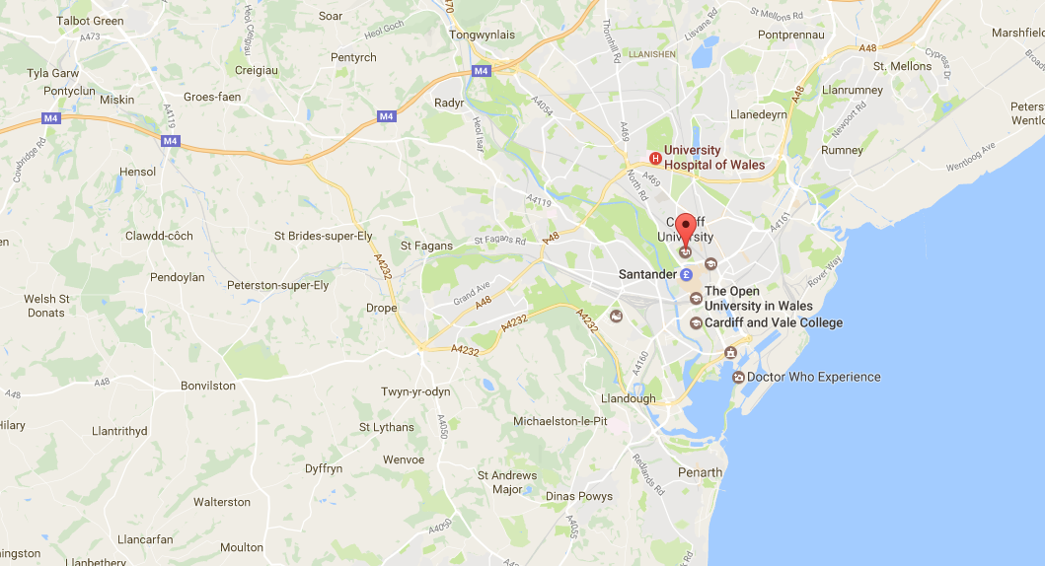

By Car

From the M4
- From the south west, take the M5 and from the south of England, follow major A roads to the M4.
- Travelling east on the M4. Leave the motorway at Junction 32, follow the A470, signposted City Centre, into the Cathays area of the city.
- Travelling west on the M4. Leave the motorway at Junction 29, follow the A48(M)/A48, signposted Cardiff East and South, to the A470. Follow the A470, signposted City Centre, into the Cathays area of the city.

Car Parking
There are three multi-story car parks close to the venue, plus many nearby on-street paid car parks.

